* Coding STM32 embedded system by Keil MDK IDE
* Building custom c library for micromouse, format function naming and calling resembling Arduino library for easy use for unexperienced teammates

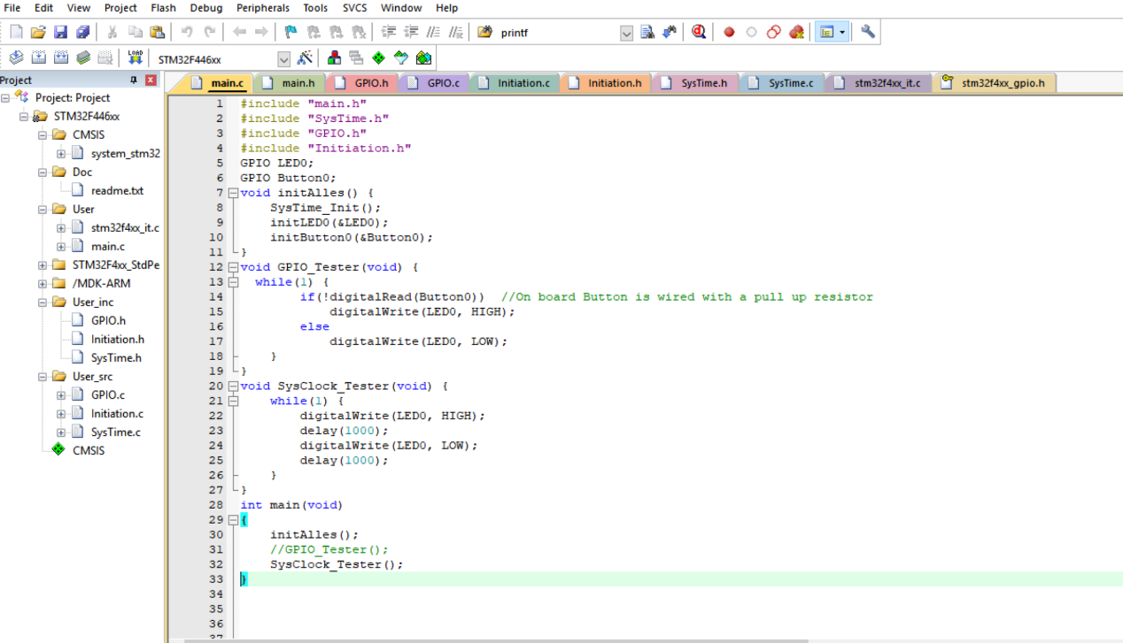

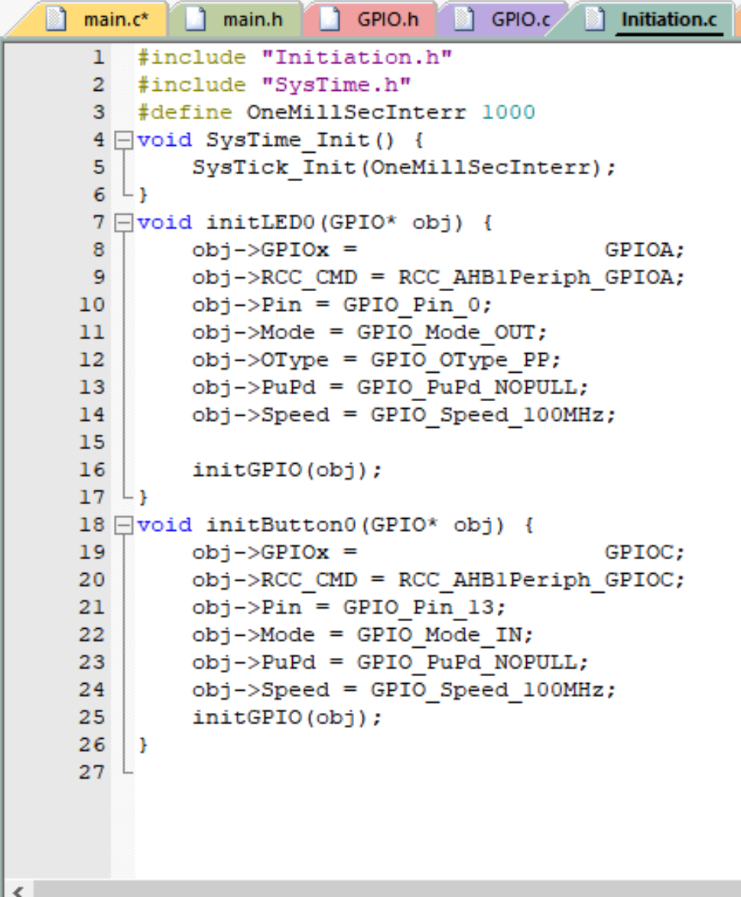

* So far, GPIO.h and SysClock.h is completed and fully tested by leds and digital analyzer (external cristal oscillator is used)

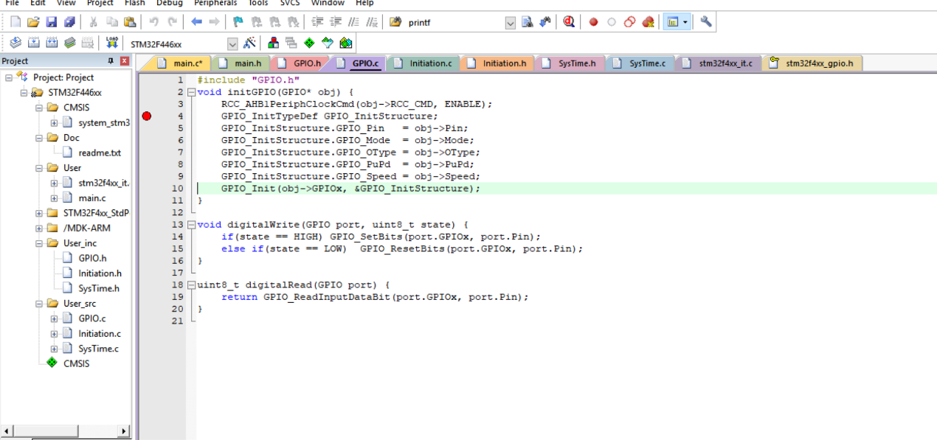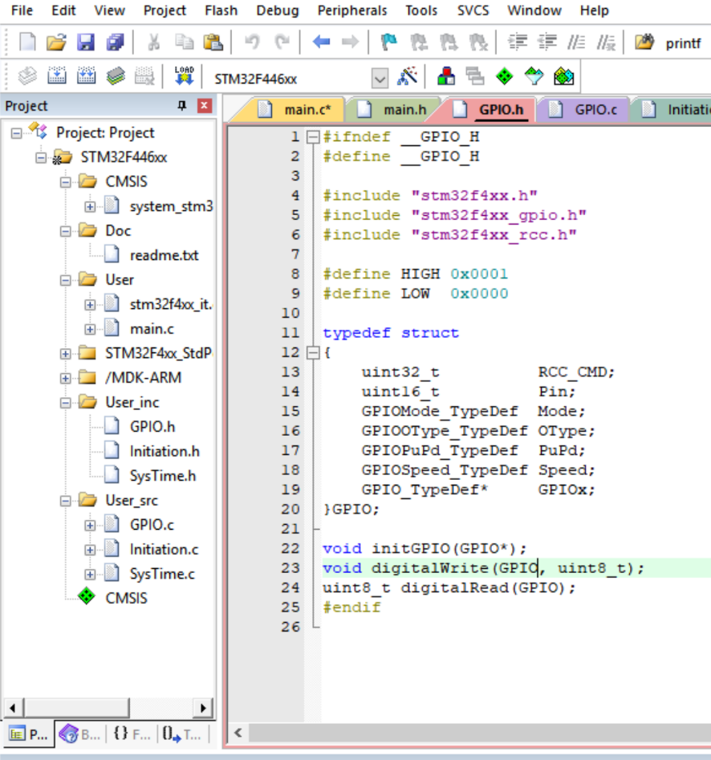

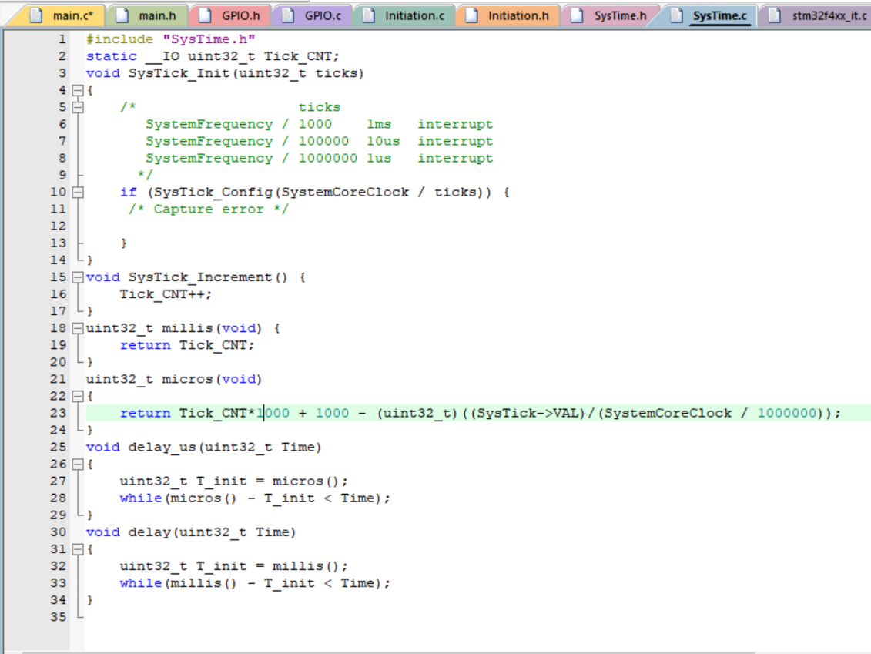

* Pwm.h and SPI.h is partially completed but not yet tested